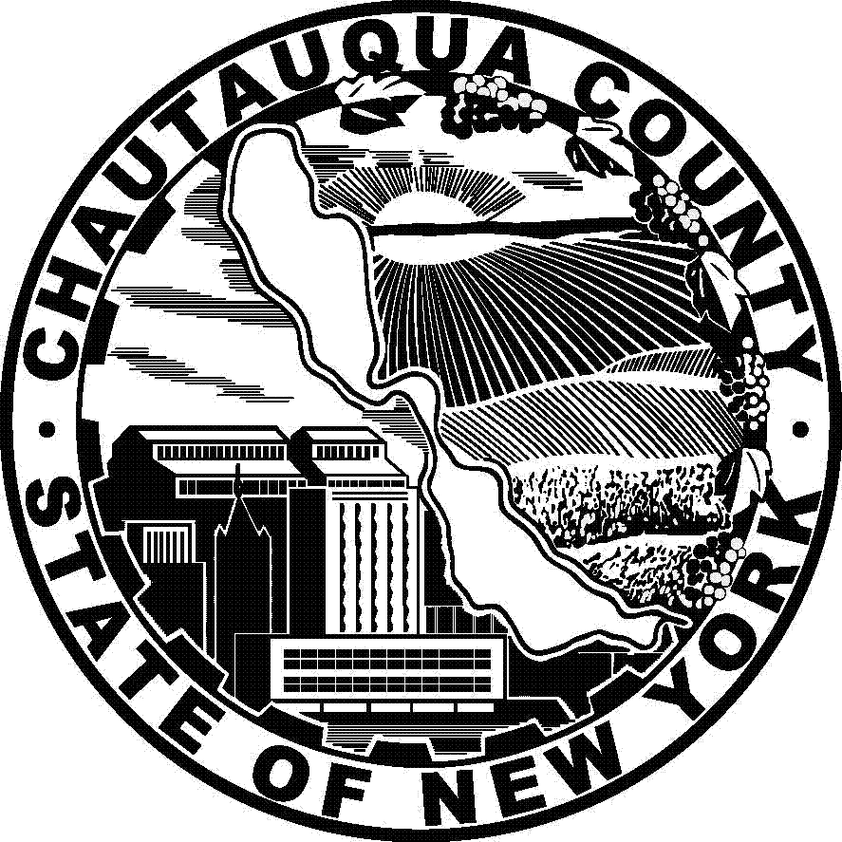
CHAUTAUQUA COUNTY HIPAA BREACH / COMPLIANCE
VIOLATION COMPLAINT FORM

It is the policy of Chautauqua County to require that all HIPAA breach or Compliance Violation Complaint reports be submitted in writing, using this Report form. Reports must be filed within 180 days of the date the person submitting the report knew or should have known of the alleged violation. The County may in its discretion waive this time limit if it determines that there is good cause for a waiver, for example in circumstances when submitting a claim within the 180 days was impossible.

Breach reports are to be submitted to:
Compliance Officer
Gerace Office Building Room #144
3 North Erie Street
Mayville, New York 14757
compliance@chqgov.com

For questions about this form or about filing a complaint, please call (716) 753-4714.

Your name: Phone Number:

Address:

E-mail address: Best time to contact you:
The more information we have, the better and more expeditiously we will be able to respond. Please provide as many details as possible, including:

(a) the date(s) of the activity:

(b) the date you learned of the activity:

(c) the number of individuals whose records were disclosed:

(d) was the recipient of the information a Covered Entity under HIPAA?

(e) please attach written confirmation that the information has been destroyed, as applicable, including by whom and when the destruction was performed.

(f) the alleged victim(s) of the event:

(g) your relationship to those involved in the event, if any:

(h) to the best of your knowledge, are all victims aware of the event?

- the name(s) of all those alleged to have caused the violation, with contact information if available:

(j) the name(s) of all witnesses, with contact information if available:

(k) the nature of the actions or inactions which have occurred, including details as to the nature of health
information disclosed and the names of each and every person who accessed the information:

(l) the means by which you became aware of the offending activity:

(m) please provide information regarding: (1) mitigation; (2) sanctions; (3) amendments to policies and/or procedures; and (4) changes to security / privacy safeguards which have taken place as a result of this event. Please also indicate whether (5) additional training has been implemented in response to this event, including when, who participated, and the subject matter of the training. Attach additional pages as necessary.

(n) additional information:

The County takes these allegations very seriously, and will investigate the matter.
There are specific procedures which the County must follow to ensure that justice prevails. It takes time to do things properly as we need to ensure compliance with Civil Service Laws, the Taylor Law, and administrative laws and procedures which apply to governments in this situation. We appreciate your patience.

FOR COMPLIANCE OFFICER USE ONLY
Complaint Number:
Date Received:

This document shall be retained six years from the date of its creation
or six years from the date it is last in effect, whichever is later (§164.530(j)(2)).

Effective Date:  October 23, 2019 | Refer to : 45 CFR 164.530(d) and 164.530(a)(1)(ii)
Authorized by: | Version #2013-2

